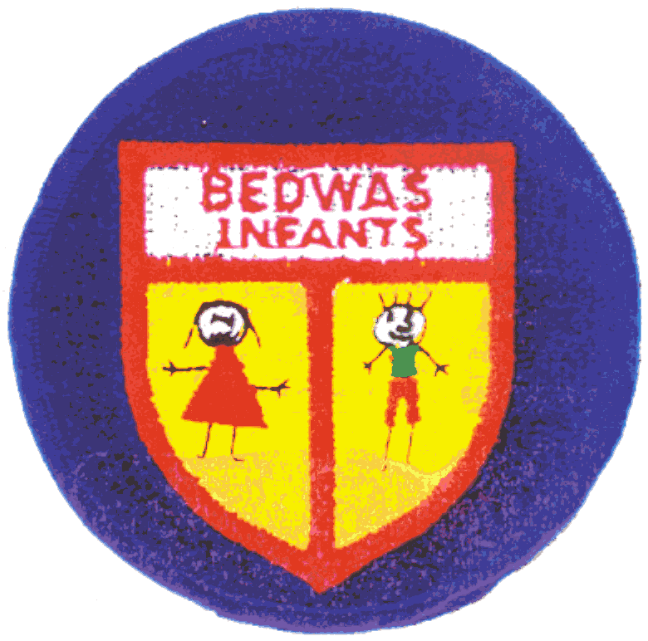Bedwas Infant School | Privacy Notice Ref No: 1  Date Created01/10/2020  Date Published:14/02/2023  Version Number:4

Contact Details: 02920852512
bwaia@caerphilly.gov.uk
Privacy Notice Name: Processing pupil information
Description of Privacy Notice: This Privacy Notice describes how the school will process personal information about pupils and families.

Summary Privacy Notice

How we will use your information

The school processes personal information about pupils and their families to support pupil learning and monitor attainment, to provide pastoral care and to keep children safe. We also process personal information to meet the statutory duties placed upon us by Welsh Government, to administer optional school trips and activities.

The school takes its responsibilities under data protection law very seriously, and will store and use all personal information securely, disposing of it when no longer required. Personal information may be shared securely for clear purposes with other organisations such as Caerphilly County Borough Council or other schools that provide a service to pupils/families. You have a number of rights in relation to your personal information including the right of access to information and the right of complaint. For further information please click the following link www.bedwasinfants.com

Bedwas Infants School | Privacy Notice Ref No:1  Date Created: 06/01/2020  Date Published:06/01/2020  Version Number:2

Contact Details: 02920852512
bwaia@caerphilly.gov.uk
Privacy Notice Name: Processing pupil information
Description of Privacy Notice: This Privacy Notice describes how the school will process personal information about pupils and families.

Full Privacy Notice
How we will use your information

Source and type of information being processed

Categories of personal data obtained

Most of the information that the school holds/uses about you has been collected from you directly, but some information may have been received from other organisations/sources, as listed below.

The school has obtained the following categories of your personal data that make up your education record:

- personal identifiers and contacts (such as name, unique pupil number, contact details and address)
- characteristics (such as ethnicity, language, free school meal eligibility and immigration status)
- safeguarding information (such as court orders and professional involvement)
- special educational needs (including the needs and ranking)
- medical and administration (such as doctors information, child health, dental health, allergies, medication and dietary requirements)
- attendance (such as sessions attended, number of absences, absence reasons and any previous schools attended)
- performance in internal and national assessments and examinations
- behavioural information (such as exclusions and any relevant alternative provision put in place)

Source of the personal data

This information has been collected from:
- Pupils/families directly, (e.g. via registration forms at the start of the school year, school trip applications, etc)
- Caerphilly County Borough Council Education Directorate
- Caerphilly County Borough Council Social Services Directorate (if applicable)
- A previous school attended by the pupil

If you would like further information on the source of this information please contact the school.

Your Obligations

Certain pupil data is essential for the schools’ operational use. Whilst the majority of pupil information you provide to us is mandatory due to a legal or contractual obligation (see below), some of it is optional, and if this is the case you will be asked to give your consent.

We will inform you at the point of collection whether you are required to provide certain pupil information to us or if you have a choice in this, and any consequences should you decide not to provide information or to subsequently withdraw consent.

Purpose and legal basis for using your information

Purpose of processing

We process personal information about pupils and their families:

- to support pupil learning
- to monitor and report on pupil progress
- to provide appropriate pastoral care
- to assess the quality of our services
- to keep children safe (food allergies, or emergency contact details)
- to meet the statutory duties placed upon us for Welsh Government data collections
- to administer trips and activities, catering and free school meal management.

Legal basis for processing

For the processing of personal data to be lawful, a prescribed legal basis is required.

- Mandatory school processing of pupil information is covered by the condition that processing is necessary for compliance with a legal obligation to which the controller is subject. The legal obligation is contained within the Education Act 1996 and associated Welsh Government regulations.

- Optional processing of personal data is covered by the Article 6 condition – explicit consent. If this is case, you have the right to withdraw consent. Please contact the school for further information.

Some other uses of data will be made in accordance with the school’s legitimate interests which includes: [provided that these are not outweighed by the impact on the individual]

- Physical or mental health or condition
- Politics
- Racial or ethnic origin
- Religion or other beliefs of a similar nature
- Sex life
- Sexual orientation
- Trade union membership
- Genetics
- Biometrics (where used for identification purposes)

Data Protection legislation also provides extra protection for personal data in relation to criminal allegations, proceedings, outcomes and sentences.

If any information falls within these categories, we will ensure that we fulfil the additional conditions for processing such information.

Who will have access to your information?

Identity of Data Controller and Data Protection Officer

The Data Controller for your information is Bedwas Infant School.

The Data Protection Officer is contracted by the school to Caerphilly County Borough Council. You can contact the school Data Protection Officer on 01443 864322 or by email at dataprotection@caerphilly.gov.uk

Details of any sharing of your information with other organisations

We must share certain pupil information with specific organisations, but only with a clearly defined reason and an appropriate legal basis under data protection law.

We always ensure that the sharing of personal information is securely undertaken.

Organisation | Reason and lawful basis
School that the pupil subsequently attends | Continuity of education - compliance with a legal obligation
Caerphilly County Borough Council | To monitor education provision and research to inform policy and funding decisions- compliance with a legal obligation  To provide IT support – performance of a contract  To provide Health and Safety support - performance of a contract  To defend insurance claims – legitimate interests (and legal proceedings  To administer Special Educational Needs support – public task  Safeguarding purposes – compliance with a legal obligation, vital interests, or public task
Welsh Government (further detail below) | Provision of statistics to monitor education - compliance with a legal obligation.
Aneurin Bevan University Health Board | To provide a school health service – public task public health  Safeguarding purposes – compliance with a legal obligation, vital interests, or public task

Sharing information with Welsh Government
The Welsh Government receives information on pupils directly from schools normally as part of statutory data collection which consists of the following:

- Post-16 data collection
- Pupil Level Annual School Census (PLASC)
- Educated other than at school (EOTAS) pupil level collection
- National data collection (NDC)
- Attendance collection
- Welsh National Tests (WNT) data collection

In addition to the data collected as part of PLASC, the Welsh Government and local authorities also receive information regarding National Curriculum assessments, public examination results, and attendance data at individual pupil level which comes from Schools and /or Awarding Bodies (e.g. WJEC).

The Welsh Government uses this personal information for research (carried out in a way that ensures individual children and young people cannot be identified) and for statistical purposes, to inform, influence and improve education policy and to monitor the performance of the education service as a whole. Examples of the sort of statistics produced can be viewed at www.wales.gov.uk/statistics. Further information is on the Welsh Governments’ use of personal data is set out within the Welsh Governments’ Privacy Policy which is available here.

Details of external data processors
Some of the schools processing activity is carried out on its behalf by third parties, such as IT systems, cloud storage providers. This is always subject to contractual assurances that personal data will be kept securely and only in accordance with the school’s specific directions. Some examples of these processors are set out below:

 | Capita SIMS (data management)
Student data processed:
pupil name and contact details, parent name and contact details, emergency contact details, pupil attendance, any dietary or medical needs, and information regarding Special Educational Needs
Captia SIMS is a Management Information System (MIS) used to store pupil information collected directly from parents/carers when a pupil joins the school. SIMS is hosted at a Microsoft Azure datacentre in the UK and data is encrypted at rest in cloud storage and as it travels across the internet or within networks.
https://www.capita-sims.co.uk/gdpr |
https://www.capita-sims.co.uk/privacy-notice

 | CCTV (public monitoring)
 | Student data processed:
CCTV is used both inside and outside the school to ensure the safety of all staff, pupils, and visitors. The school CCTV is monitored by CCBC and data is stored in Tir-Y-Berth.
https://www.caerphilly.gov.uk/My-Council/Data-protection-and-freedom-of-information/Privacy-notices

 | Evolve (risk assessments)
 | Student data processed: full name, DOB, class
Evolve assists the school in risk assessing school trips for staff, visitors, and pupils. Data is stored in databases within the United Kingdom and each server has Proactive Threat Monitoring to detect any intrusion attempts.
https://evolve.edufocus.co.uk/evco10/privacy.asp | http://edufocus.co.uk/pages/evolve/gdpr.asp

 | Thrive Online (emotional/social development support)
 | Student data processed: Names, UPN, class, and date of birth
Thrive Online is used to support pupils with building on progress and development in the curriculum and everyday life experiences. Any personal information provided to Thrive will be held within the European Economic Area. Only some pupils are involved in this intervention.
https://www.thriveapproach.com/privacy-policy/privacy-policy-2/


INCERTS The Assessment Foundation (pupil progress)
Student data processed: full name, DOB, class, assessment data
INCERTS The Assessment Foundation supports the school to track pupil progress and is an online assessment tool. It helps us track what your child knows, understands, and can do so that we can help plan the next steps. INCERTS also supports reporting progress to parents and carers.
http://www.assessmentfoundation.org/privacy.html

 | Microsoft Outlook (communication)
 | Student data processed: full name, DOB, class
Microsoft Outlook is an email system that supports the Senior Management Team with business administration and communicating with the Local Authority. Data is stored in UK Data Centres and Microsoft control staff access to personal data. Microsoft ensure data is encrypted when stored in their Data Centres and when it travels across the internet.
https://www.microsoft.com/en-us/trust-center/privacy/gdpr-overview | http://www.microsoftvolumelicensing.com/DocumentSearch.aspx?Mode=3&DocumentTypeId=46

 | Google for Education (learning support/communications)
 | Student data processed: full name, DOB, class
Google for Education (i.e. Gmail, Google Drive, Docs/Sheets/Slides) is used by the school to create assignments, communicate with students through a school-wide email system for teachers, provide feedback on student work, and track student progress within classes. Data is encrypted and information is stored securely within UK Data Centres. Google monitor staff access controls and there is a strict security monitoring program in place to detect any unauthorised access to the network or by employees.
https://cloud.google.com/security/gdpr/resource-center/

 | HWB (national assessments/additional services)
 | Student data processed: pupil names, year groups, assessment data
 | HWB is a Welsh Government digital learning website. It allows learners access to Microsoft packages and various other software. Hwb is linked to Captia SIMS and extracts information. All pupils in maintained schools in Wales must be provided with a secure log-in to the Hwb platform due to mandatory reading and numeracy tests. https://hwb.gov.wales/privacy

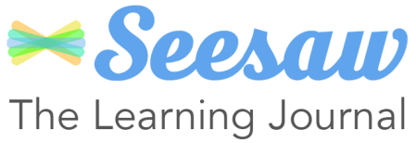 | SeeSaw (online learning journal)
 | Student data processed: full name, DOB, class, photographs
Seesaw is a secure online journal where students can document and reflect on what they are learning in class. Pupil work will never be identifiable when using Seesaw apart from in their own file which will be labelled with their first name only. The Seesaw Service is hosted and operated in the United States and complies with the EU-US Privacy Shield Framework. They contract Amazon Web Services to provide data centre and server hosting services.
https://web.seesaw.me/privacy-policy/ | https://www.privacyshield.gov/participant?id=a2zt000000001DLAAY&status=Active

 | Reading Eggs
Reading Eggs is an online programme designed to work from the classroom or at home. More information regarding the programme and how it collects and stores data can be found via the link below.

(https://readingeggs.co.uk/privacy).
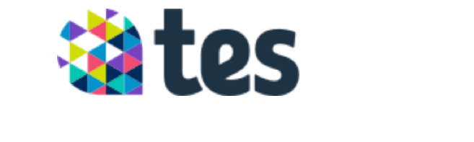Edukey
Edukey is an online tool for ALN and Safeguarding records.
https://www.tes.com/terms-conditions/privacy-policy

Requests for information

All recorded information held by the school may be subject to requests under the Freedom of Information Act 2000, Environmental Information Regulations 2004 and data protection law (General Data Protection Regulations 2016 and Data Protection Act 2018).

If the information you provide is subject to such a request, where possible the school will consult with you on its release. If you object to the release of your information we will withhold your information if the relevant legislation allows.

How long will we retain your information.

We hold pupil data securely for the set amount of time documented in our data retention schedule.
- Primary schools will retain information whilst the child remains at the primary school, and securely transfer the information to the secondary school or alternative provision when the child moves on.
- Secondary schools will retain information about pupils and their families for 25 years after the pupil’s birth date.

Information with historic value will be transferred to Gwent Archives but any personal information will be subject to an appropriate closure period so that it is restricted from public inspection.

For more information contact Gwent Archives on 01495 353363 enquiries@gwentarchives.gov.uk www.gwentarchives.gov.uk

Your Rights (including complaints procedure)

Your rights under data protection law

Data protection law gives data subjects (those who the information is about) a number of rights:

- The right of subject access
- The right to be informed
- The right of rectification
- The right to erasure
- The right to restrict processing
- The right to object
- The right to data portability
- Rights in relation to automated decision making and profiling.

Further information on your rights is available from: www.ico.org.uk.

To exercise your rights please contact the school.

Complaints Procedure

If you are unhappy with the way that the school has handled your request / information, you have the right of complaint. Please contact the school outlining your concerns in the first instance.

If you remain unhappy you can contact the schools Data Protection Officer on 01443 864322 dataprotection@caerphilly.gov.uk

You can also complain to the Information
Commissioner's Office on 029 2067 8400.

